**HTML Links Colors**

**State of Link Colors:**

An HTML link is displayed in a different colors in all browsers because there are 3 states of link colors depending on whether it has been visited, is unvisited, or is active.

By default, links will appear like this in all browsers:

* An unvisited link is underlined and blue
* A visited link is underlined and purple
* An active link is underlined and red

***Unvisited Link displays like this:***

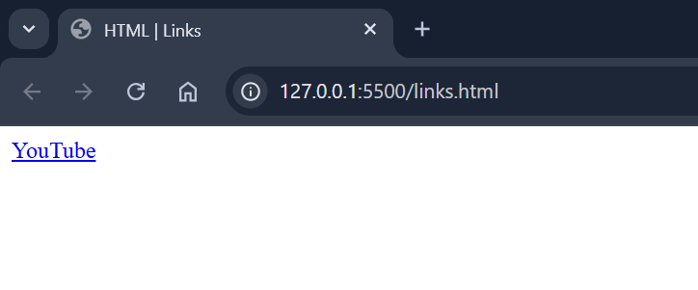

***Visited Link displays like this:***

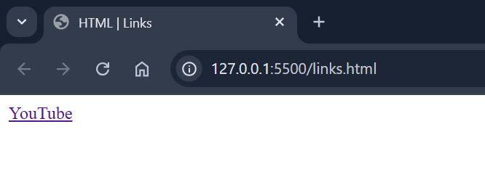

***Active Link displays like this:***

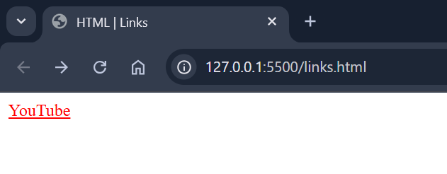

**Tip:** Links can of course be styled with CSS, to get another look!

**Change Link Colors:**

You can change the link state colors, by using CSS:

**Code:**

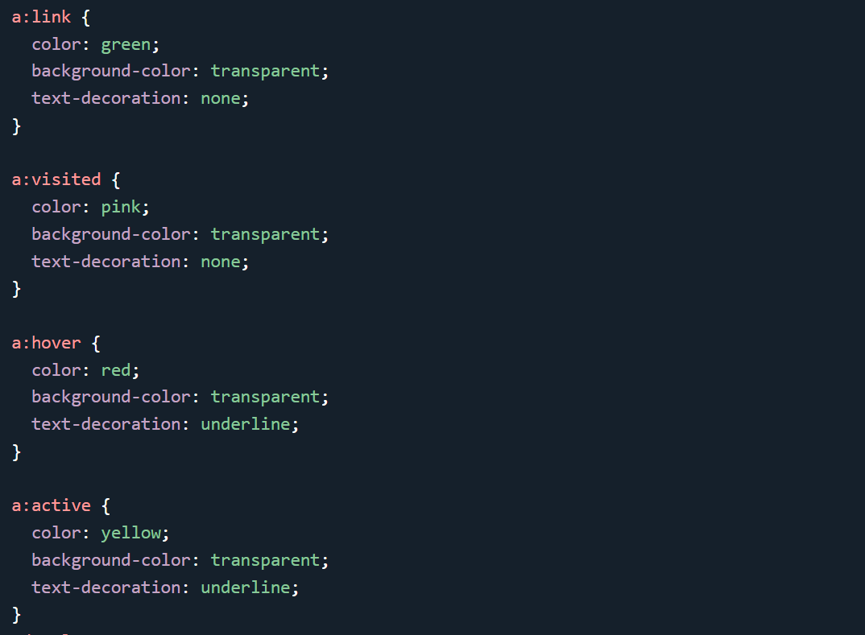

**Output:**

***visited Link color:***

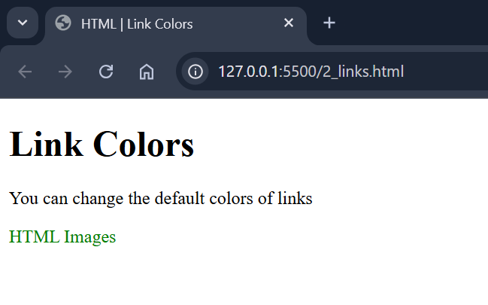

***Link color on hover:***



***visited Link color:***



***Active Link color:***

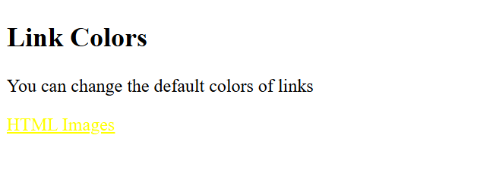

**Style Link as a Button:**

 link can also be styled as a button, by using CSS:

**Code:**

***HTML Code:***

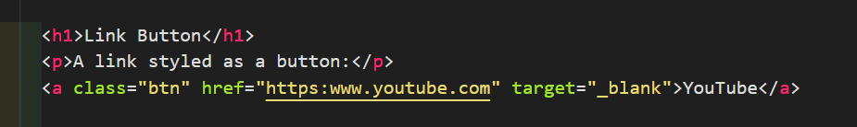

***CSS Code:***

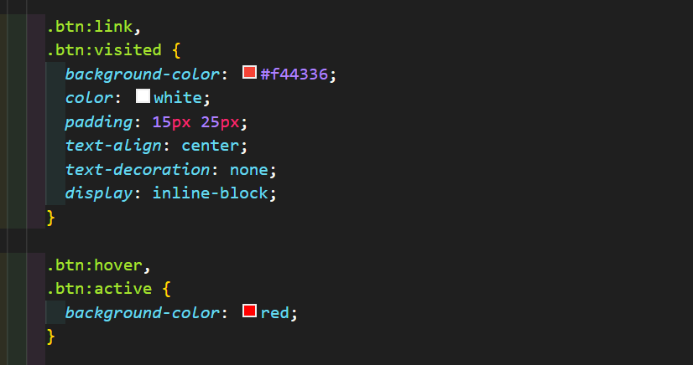

**Output:**

***Unvisited link:***

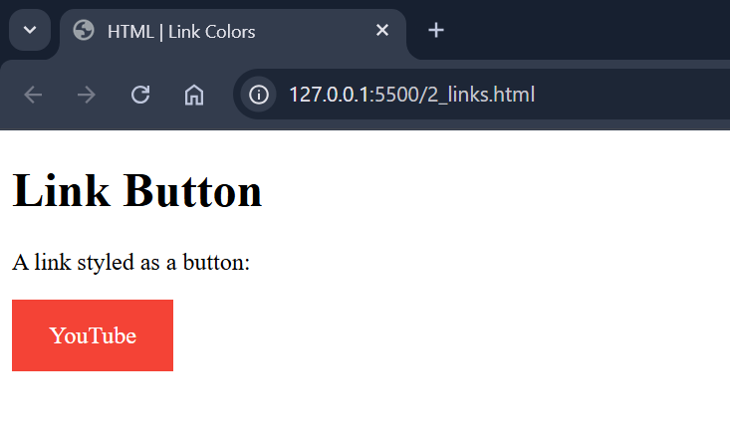

***Hover on link:***

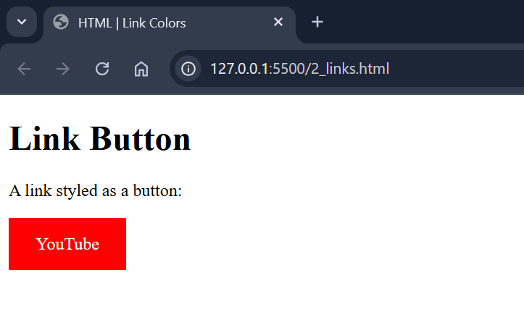

***Active link:***

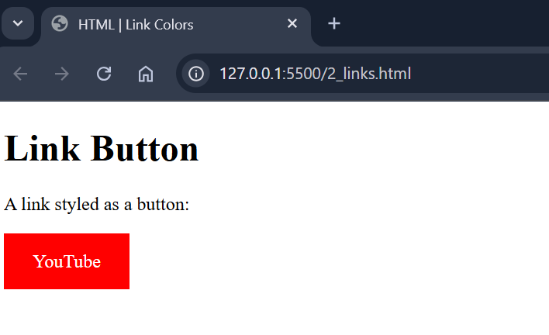

***Visited link:***

